An example of abstract for the Spanish Fluid Mechanics Conference
Alonso de Entrerríos¹ and Laurencio de los Montes^{2,*}
¹Department of Historical Research, Ministry of Time, SPAIN
²Department of Applied Paper Writing, University of Publishing, SPAIN

This document is meant as a template for the abstracts submitted to the 2nd Spanish Fluid Mechanics Conference. While not having to be long (we ask the authors not to exceed two pages), still we encourage contributors to use their abstracts as seeds for future forthcoming papers. In this document we explain how to include figures, tables, equations and references in the abstract.

INTRODUCTION
This abstract template has been adapted from the LaTeX version of the template, which is based on the REVTeX4-2 standard, the same used, among others, in the APS journals (Physical Review Fluids, Physical Review Letters, …). This template is also available in the OverLeaf LaTeX editor. Nonetheless, since you are using the DOCX version, there is no need to download it from the website of APS [1].
To put our work into context, it is useful to include references. Let us cite a classic paper [2] and a classic book [3]. Starting this abstract with these references, what can possibly go wrong?
EQUATIONS, FIGURES AND TABLES
This section is devoted to explain how to include equations, figures and tables. We start with a very good-looking integro-differential equation,
$$\begin{aligned}\frac{dh}{dt}=\int_{0}{G\left(t−τ\right)h\left(τ\right)dτ−κh}, \\ \left(1\right)\end{aligned}$$
that must be integrated with the initial condition $h\left(0\right)=0$. The kernel $G\left(t−τ\right)$ in equation (1) is not really important, as we do not plan to actually integrate the equation. So, its definition can be omitted without loss of generality.
Something that we usually like including in papers are plots, like the one shown in figure 1. Finally, we will also include here table I.

Case | Parameter 1 | Parameter 2 | Misterious Parameter
I | 400 | 12 | 1.4
II | 500 | 12.5 | 1.6
III | 500 | 12.5 | 2.2
TABLE I. Nice table showing totally random values.

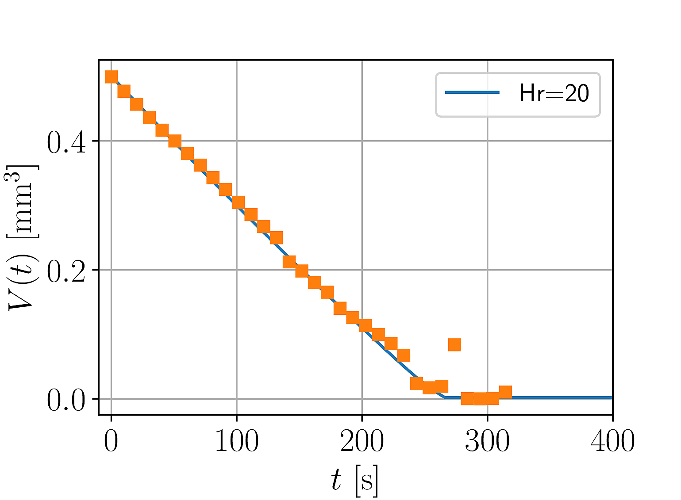
FIG 1. This plot shows the time evolution of the volume of an evaporating sessile water drop. The orange squares are the experimental values, while the blue solid line is a theoretical calculation that only considers the diffusion of water vapor in air.
CONCLUSIONS
We have shown how to include equations, references, figures and tables in the abstract template for the 2nd Spanish Fluid Mechanics Conference. I hope people find this useful and, most importantly, that we have a great conference in Barcelona in July!
—
* ldelosmontes@funnynames.com
[1] American Physical Society, “REVTeX Home Page”. https://journals.aps.org/revtex (Last visited: January 19th, 2022)
[2] Liñán A. (1974) “The asymptotic structure of counterflow diffusion flames for large activation energies”. Acta Astronautica, 1, 1007—1039.
[3] Riley N. & Drazin P. (2006) “The Navier—Stokes Equations: A Classification of Flows and Exact Solutions”. Cambridge University Press.

