INSERT HERE YOUR TITLE: M2P - A NEW ECCOMAS THEMATIC CONFERENCE & IACM SPECIAL INTEREST CONFERENCE

First A. Author*, Second B. Author†, Third C. Author†
* Affiliation
Postal Address
E-mail address and URL

† Affiliation
Postal Address
E-mail addresses and URL

ABSTRACT
People interested in presenting a contribution to M2P 2023 are requested to electronically submit an abstract no later than February 15, 2023. Abstracts have a maximum length of two pages including figures and references. They are expected to briefly outline the main ideas, results and conclusions of the research.
Abstracts have to be written in English, following the format of this template that can be downloaded from the Conference website. Before submission, abstracts have to be exported into Portable Document Format (PDF). The submission has to be done via the Conference website.
Abstracts have to contain the full name and the full address of each author, together with the email address (a webpage address is not mandatory). In the case of a joint authorship, the name of the author who will actually present the paper at the Congress has to be underlined. Contributions will be accepted only on the understanding that they will be presented at the Conference. A unique contribution is allowed to each speaker.

For any further request, please contact the Conference Secretariat:
Alessio Bazzanella
CIMNE Congress Bureau
Campus Nord UPC Edifici C3
Zona Comercial Jordi Girona, 1-3
08034 Barcelona, Spain www.cimne.com
Tel: +34 93 405 46 96
E-mail: M2P_Conference-Secre@cimne.upc.edu
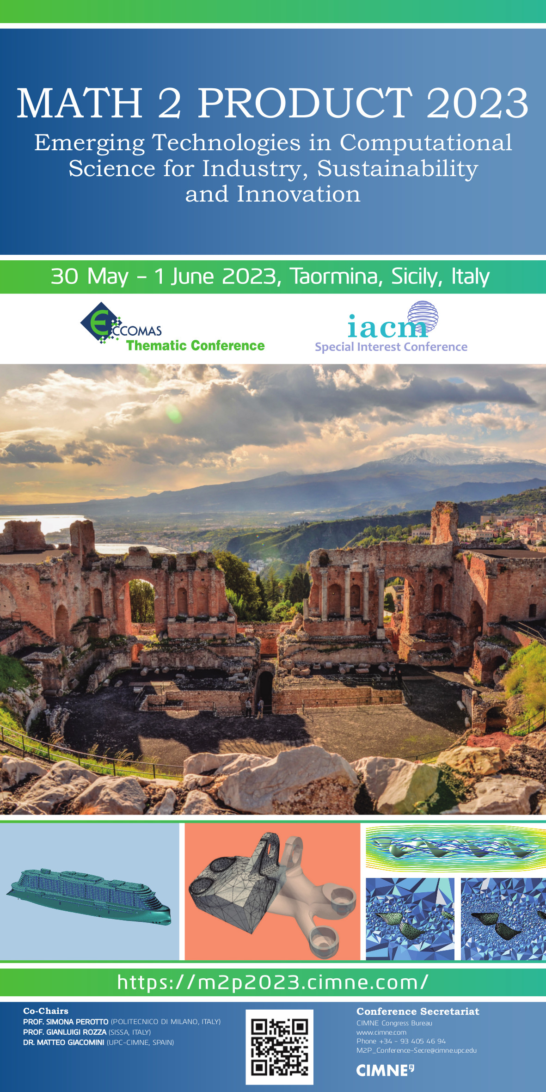
Fig 1. M2P poster, please feel free to share it with your colleagues.

REFERENCES
- J. García-Serna, L. Pérez-Barrigón, M.J. Cocero, New trends for design towards sustainability in chemical engineering: green engineering. Chemical Engineering Journal (2007) 133: 7–30.
- J. Roe, R. Deforest, S. Jamshidi, Mathematics and Sustainability. Texts for Quantitative Critical Thinking. Springer, Cham (2018).

